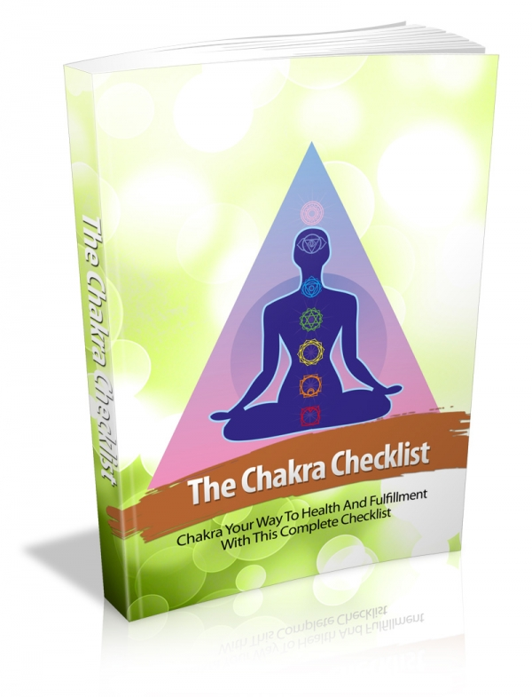

FRONT COVER:

Terms and Conditions

LEGAL NOTICE

The Publisher has strived to be as accurate and complete as possible in the creation of this report, notwithstanding the fact that he does not warrant or represent at any time that the contents within are accurate due to the rapidly changing nature of the Internet.

While all attempts have been made to verify information provided in this publication, the Publisher assumes no responsibility for errors, omissions, or contrary interpretation of the subject Matter herein. Any perceived slights of specific persons, peoples, or organizations are unintentional.

In practical advice books, like anything else in life, there are no guarantees of income made. Readers are cautioned to reply on their own judgment about their individual circumstances to act accordingly.

This book is not intended for use as a source of legal, business, accounting or financial advice. All readers are advised to seek services of competent professionals in legal, business, accounting and finance fields.

You are encouraged to print this book for easy reading.

Table Of Contents

Foreword
Chapter 1:
The Basics Of Spiritual Discovery

Chapter 2:
About Meditation

Chapter 3:
Meditation Techniques

Chapter 4:
The Throat and Chakra Connection

Chapter 5:
How To Tips

Wrapping Up

Foreword

The chakras are described as being aligned in an ascending column from the base of the back to the top of the head. New Age practices frequently associate each chakra with a particular color.

In assorted traditions chakras are affiliated with multiple physiological functions, an facet of consciousness, a classical element, and other distinguishing features. They're visualized as lotuses/flowers with a assorted number of petals in every chakra.

The chakras are thought to vitalize the physical body and to be affiliated with interactions of a physical, emotional and mental nature. The purpose of the chakras is to spin and attract in energy to keep the spiritual, mental, emotional and physical wellness of the body in balance.

They're stated by some to reflect how the unified consciousness of humanity is divided to manage assorted facets of earthly life. It is as well associated to spiritual healing.

The Chakra Checklist
Chakra Your Way To Health And Fulfillment With This Complete Checklist

Chapter 1:
The Basics Of Spiritual Discovery

Synopsis

When people embark on a journey of self-discovery, they commonly focus on the physical and emotional side of their personality. Rarely do people consider the importance of spiritual self-discovery, even if they identify as spiritual side to their personality. When we take the time to explore the part of our psyche that we sometimes call spirit or soul, we discover a unique and different aspect to our personality we may not even have realized existed.

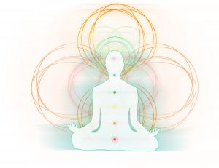

The Journey

We are people made up of physical, spiritual, intellectual and emotional dimensions. We experience the world and the experiences we go through in the world, by looking at them through these dimensions. This is not new.

We know that humanity has always considered these dimensions. Roman and Greek mythology, Roman astrology and ancient religions are all testimony to the very real role that spirituality has played in human development.

We perhaps identify best with the moment we see a magnificent sunrise, or an amazing act of nature that leaves us in a state of bewilderment and wonder, recognizing there are things in our life that are beyond our ability to control. We have a conscious or unconscious desire to know this power and it is what we can term spirituality.

When people think of spiritual wellbeing, they commonly think of God. Whoever or whatever they conceive “him” to be. Some consider him a supreme being and others consider him as “the man upstairs” a belligerent father figure. Still others reject the concept of any sort of being, and find their spirituality in the earth, or in nature.

So how do we discover the spiritual side of our personalities? Some people discover it through embracing formal religion, others discover it through yoga or some other form of meditation that causes them to focus in on themselves and still others go on a journey of self-discovery and call this a religious experience.

Some have compared this spiritual awakening with a heightened sense of experiencing. As we allow our inner selves to experience life at a deeper level than just what seems obvious around us, we begin to relate to things in a different way.

In whatever we choose to embrace the spiritual side of our personality, when we do focus on spiritual self-awareness we commonly discover we come alive in our personality and this has an effect on how we relate to self and others.



Chapter 2:
About Meditation

Synopsis

Spirituality entails a lot of practices; some are physical some are spiritual. Physically, there are activities such as singing of religious hymns or even sitting on the wheel of prayer.

As a matter of fact, some go to an extent of doing certain physiological body routines before performing any spiritual activity. However, one of the main activities that link both spiritual and physiological activities is meditation.

This is the process through which many spiritual individual tend to connect with their inner spiritual realm and even connect with God. All in all, not everyone understands the importance of meditation in spirituality. This can only be explained by understanding the power of meditation.

Behind It

Meditation is a vital tool for anyone who wishes to grow spiritually. For those who ignore meditation, they tend to suffer from unease. Notice the difference; dis-ease and disease. The latter is a disorder in the body while the other is a disorder in the spiritual self that results in some sort of discomfort.

This is mainly brought about by that disconnection with God. In relation to this, meditation tends to connect our souls with God hence bringing about growth of the spiritual self. This is the main power of meditation in terms of spiritual.

Basically, meditation is said to have several benefits to the mind, body and soul. This is because the three are linked together to form the real you. As for the soul, it gets its nourishment from our connection with God which can only be achieved by regularly meditating. Therefore, not meditating is denying the soul its food.

This is hazardous; just like denying the physical body food. With this trend, we might end up starving to death and the same will happen to the soul. And a body without a soul is ‘dead’. Therefore, if you feel some unease, the n that is a sign that your soul is starving. Take action before tings get worse.

On the other hand, there are various levels of meditation each meant to serve a particular purpose. Many have the will to meditate but end up frustrated in the end due to lack of results. Why do you think this happens? It is simply because they perform the wrong meditation practices for their level hence bearing no results.

For more information on meditation levels, consult a meditating expert who will give you directions on the various meditation levels and their uses. Therefore, you will be in a position to choose.

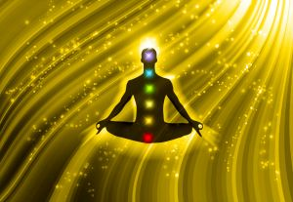

Chapter 3:
Meditation Techniques

Synopsis

Although there are many different approaches to Chakra meditation, the fundamental principles remain the same. The most important among these principles is that of removing obstructive, negative, and wandering thoughts and fantasies, and calming the mind with a deep sense of focus. This clears the mind of debris and prepares it for a higher quality of activity.

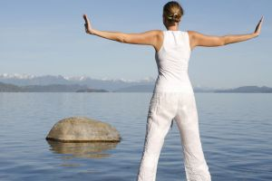
Strategies

The negative thoughts you have – those of noisy neighbors, bossy officemates, that parking ticket you got, and unwanted spam– are said to contribute to the ‘polluting’ of the mind, and shutting them out is allows for the ‘cleansing’ of the mind so that it may focus on deeper, more meaningful thoughts.

Some practitioners even shut out all sensory input – no sights, no sounds, and nothing to touch – and try to detach themselves from the commotion around them. You may now focus on a deep, profound thought if this is your goal. It may seem deafening at first, since we are all too accustomed to constantly hearing and seeing things, but as you continue this exercise you will find yourself becoming more aware of everything around you.

If you find the meditating positions you see on television threatening – those with impossibly arched backs, and painful-looking contortions – you need not worry. The principle here is to be in a comfortable position conducive to concentration. This may be while sitting cross-legged, standing, lying down, and even walking.

If the position allows you to relax and focus, then that would be a good starting point. While sitting or standing, the back should be straight, but not tense or tight. In other positions, the only no-no is slouching and falling asleep.

Loose, comfortable clothes help a lot in the process since tight fitting clothes have a tendency to choke you up and make you feel tense.

The place you perform meditation should have a soothing atmosphere. It may be in your living room, or bedroom, or any place that you feel comfortable in. You might want an exercise mat if you plan to take on the more challenging positions (if you feel more focused doing so, and if the contortionist in you is screaming for release). You may want to have the place arranged so that it is soothing to your senses.

Silence helps most people relax and meditate, so you may want a quiet, isolated area far from the ringing of the phone or the humming of the washing machine. Pleasing scents also help in that regard, so stocking up on aromatic candles isn’t such a bad idea either.

The monks you see on television making those monotonous sounds are actually performing their mantra. This, in simple terms, is a short creed, a simple sound which, for these practitioners, holds a mystic value.

You do not need to perform such; however, it would pay to note that focusing on repeated actions such as breathing, and humming help the practitioner enter a higher state of consciousness.

The principle here is focus. You could also try focusing on a certain object or thought, or even, while keeping your eyes open, focus on a single sight.

One sample routine would be to – while in a meditative state – silently name every part of your body and focusing your consciousness on that part. While doing this you should be aware of any tension on any part of your body. Mentally visualize releasing this tension. It works wonders.



This preview copy ends here and to get the full product, please go to (the website URL ) here to get the full product.

